**For the Tool we required Python 2.7.15 64 bit**

1. Need to install python
2. After that add path to enviromenet variable. It can be done by below attacehd pic
3. Right click on my computer then added path in path variable

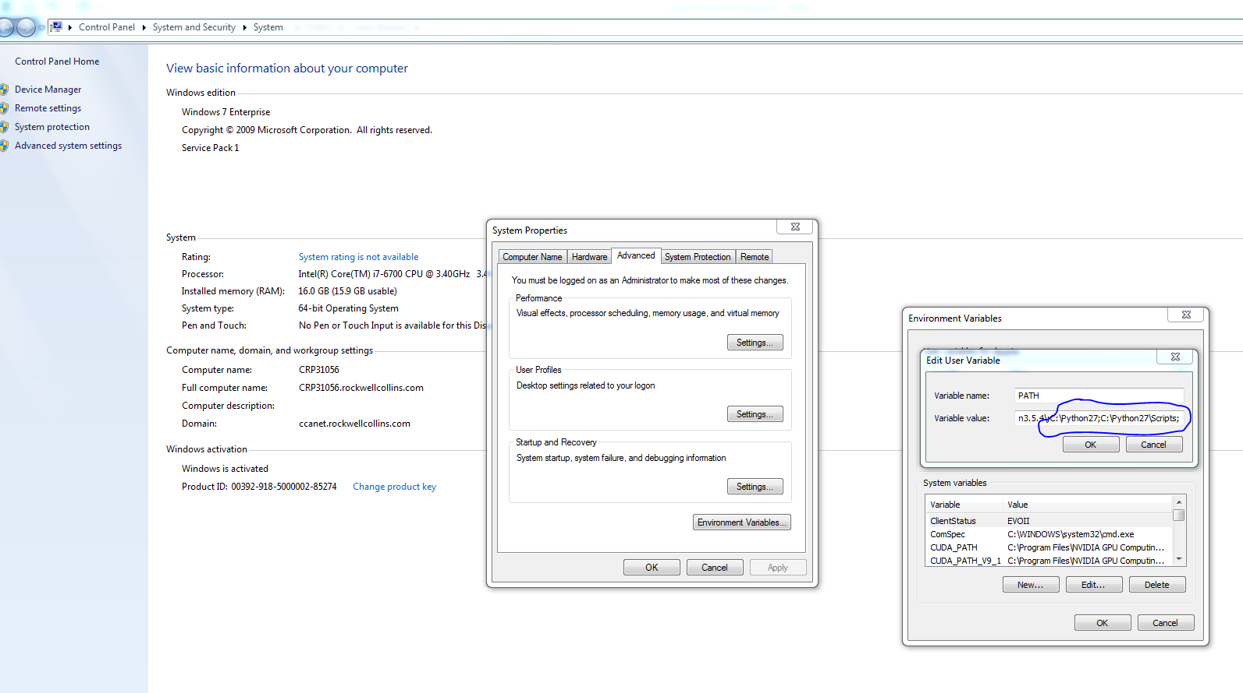

1. Go to **\\ccanet\cs\FMS\fmsprojects\Public\Team Sherpas\Auto Jama Proxy Tool\Auto Jama Proxy\venv\Lib\site-packages**

And copy the entire site-package and copy in your **C:\python27\Lib\site-package**

**Follow the steps to Run the Tool**

**Step 1:** double click on findout_downstream_links.bat or open the command prompt and navigate to findout_downstream_links.py then hit enter

Click the batch file

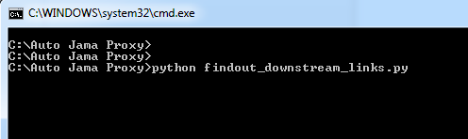

or

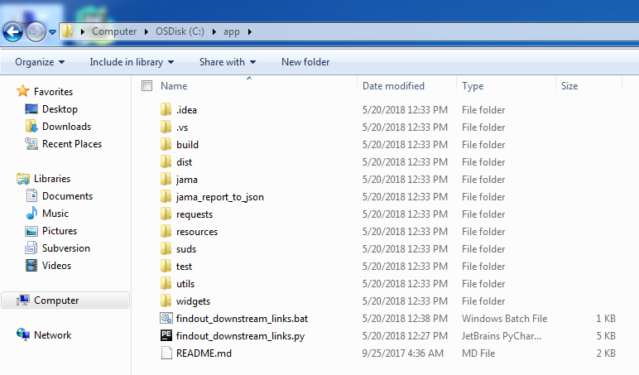

**Setp2: Login with your Jama credential**

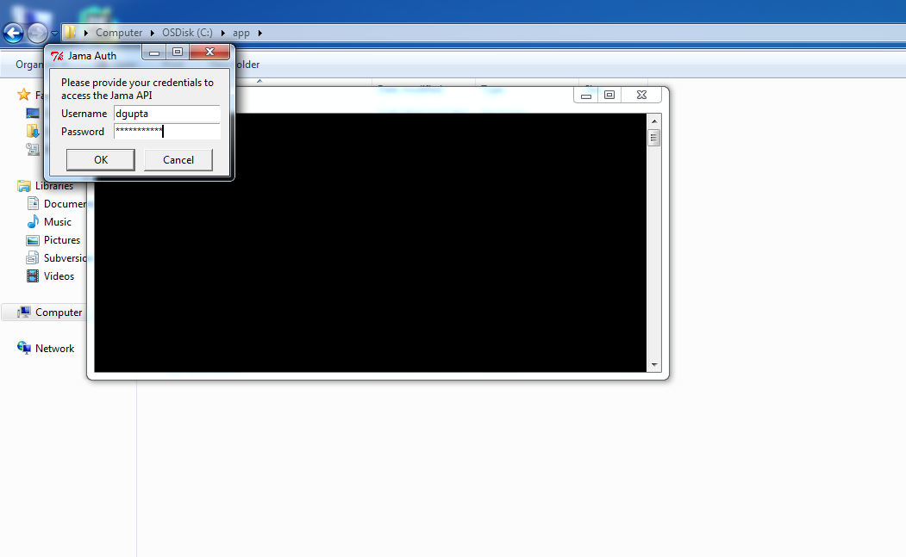

**Stpe3:** Get the Master Feature Id:

Search the master feature in Jama and go to the browser tab and copy the global id

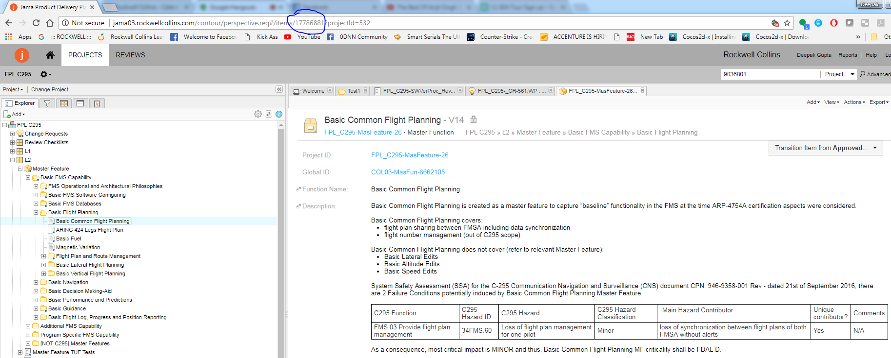

**Step4:** Copy the Id to Gui then Hit the Get DStream Id button

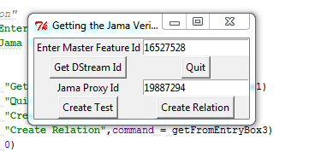

**Step 5:** Get the downstream ID’s in the Text File

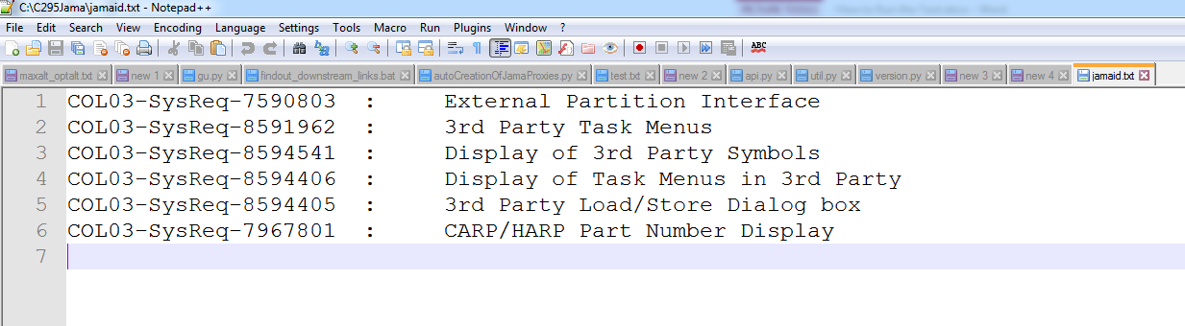

**Step 6:** Create the Test Case on the Give Jama Proxy Folder



**Note: Jama Proxy Id – select on the folder where want to create the proxy then go to browser tab and gat the id from there as we did for master feature id**

**Step 7:** Hit the Create Test Button

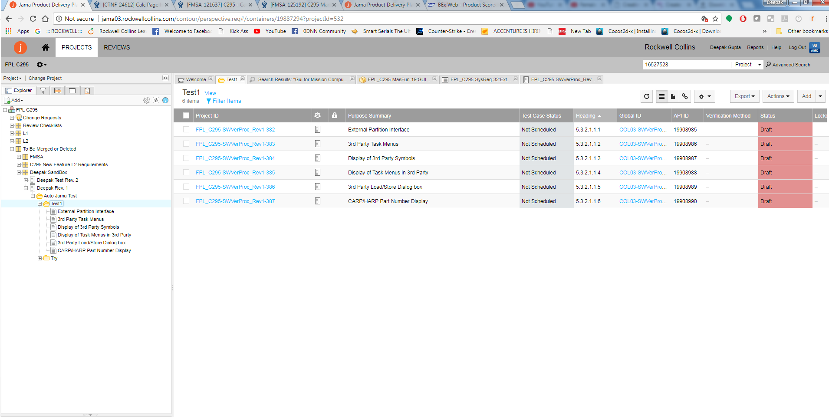

**Step 7:** On the Gui Select the Create Relation Button



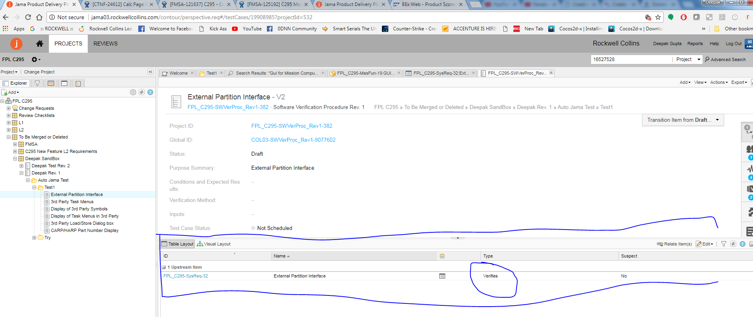

All the Created proxy will link to the given requirement